THE CATHOLIC DIOCESE OF NDOLA
THE EARLY HUMBLE BEGINNING OF BWANA MKUBWA
(THE BIRTH PLACE OF THE CATHOLIC DIOCESE OF NDOLA)

Introduction:
The Catholic Diocese has embarked on a project of enriching the first place of its origin. Recently the Diocese through its administrative structures, decided that a Shrine be erected at the place where the pioneers in establishing the Diocese first settled to begin their evangelization mission on the Copperbelt Province of Zambia.
Bwana Mkubwa is a very important place in the history of the Catholic Diocese of Ndola. Thus, before embarking on the establishment of the named Shrine, it is important to understand where we are coming from as Diocese.

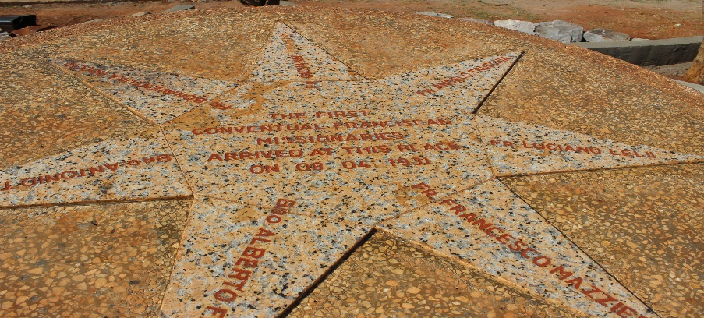
The Foundation Stone at Bwana Mkubwa enshrined the names of the founding friars to symbolize the pioneers of the Church on the Copperbelt

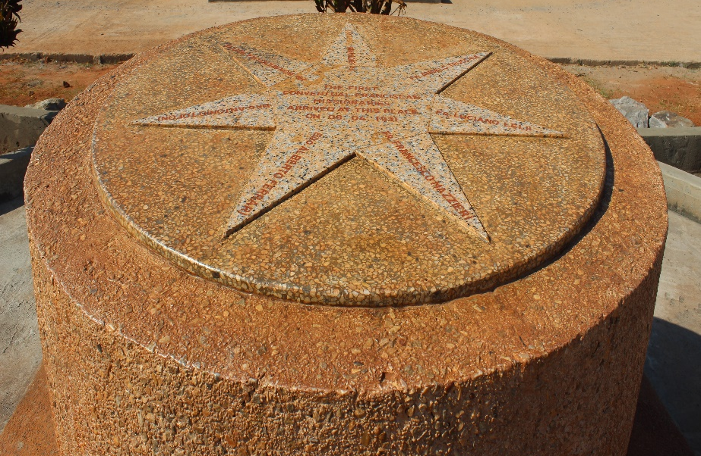

The foundation stone is erected right at the front of the first Church building the friar built at Bwana Mkubwa.

The Beginning:
1930 - June 6th: Seven Conventual Friars embark the steamship Majella at Venice. They were: Fr. Francis Mazzieri (the leader of the group), Fr. Lucian Lelii, Fr. Angelo Trucchia, Fr. Bonaventure Rocchi, Fr. John Evandri, Bro. Anthony Tofoni (all from the Marches Province), and Bro. Alberto Ferrari (from the Province of Padua). From there the Majella loads coal at Albona d’Istria, then stops at Fiume (now: Rijeka, Croatia), where they hear about the election of the new Minister General and where they finally leave Italy from on 10th June.
- July 26th: the seven friars enter Northern Rhodesia (now Zambia) at Mpulungu Port, Lake Tanganyika and live for some months in various Missions run by the Missionaries of Africa in the North-Eastern part of the country (Rosa, Chilubula, Malole; then Lubushi, Ipusukilo, Lufubu).
Between October 1930 and January 1931 come to know that their destination may change, because of preoccupations in their regards by the two Apostolic Delegates in Pretoria and Mombasa.
1931 - January 13th: The Congregation of Propaganda Fide entrusts to the Friars Minor Conventual of the Province of the Marches the District of Ndola, in the Apostolic Prefecture of Broken Hill (then amounting to the Western part of North Rhodesia). The friars receive the information on 26th January from their Minister Provincial in Italy; while on 19th March the Apostolic Prefect asks them to proceed to their destination.
- March 28th (Palm Sunday’s eve): Fr. Mazzieri, Fr. Lucian Lelii and Bro. Anthony Tofoni leave Rosa Mission for Broken Hill (now Kabwe, seat of the Apostolic Prefect for the entire Western part of North Rhodesia), where they arrive on 2nd April (Maundy Thursday), welcomed by the Prefect, Mons. Bruno Wolnik, s.j.
- April 8th (Easter Wednesday): Fr. Mazzieri and Fr. Semieski, s.j. arrive at Bwana Mkubwa and rent the dismissed Mine Club House as first residence for the friars (Rivotorto).
- April 13th: Fr. Lucian Lelii and Bro. Anthony Tofoni arrive at Bwana Mkubwa.
- April 23rd: Fr. Angelo Trucchia arrive at Bwana Mkubwa from Lufubu mission, after riding up to Elisabethville (now: Lubumbashi, Congo: close to 300 km) and then by train southwards.

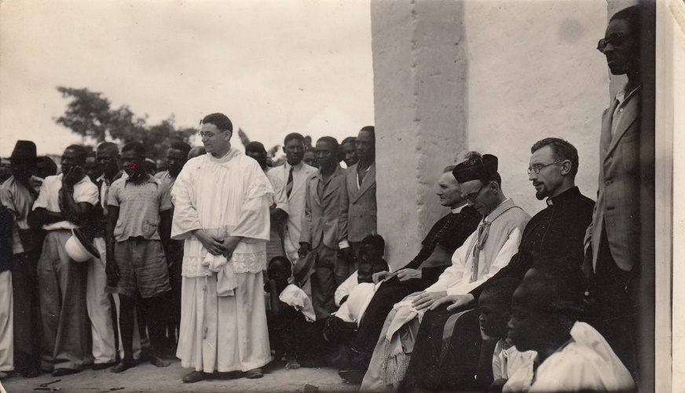 Opening of the church and welcoming of pioneer friars
- May 20th: Fr. John Evandri, Fr. Bonaventure Rocchi and Bro. Alberto Ferrari arrive at Bwana Mkubwa from Bangweulu.
- June 10th: Frs. Lucian Lelii and John Evandri take up residence in the Roan Mine Township, in the Cator Hut next to one of the previously existing burnt-brick churches in the region; by July 14th an equally small burnt-brick house is built next to it.
- June 13th: Bro. Alberto Ferrari is escorted by Fr. Mazzieri to Broken Hill, from where he proceeds for Italy, leaving the mission for good.
1932 - September 26th: The Apostolic Delegate from South Africa [based at Pretoria], Mons. Bernhard Jordan Gijlswijk o.p., visits Ndola, together with the Apostolic Prefect of Broken Hill, and is informed about the difficulties encountered in opening a rural mission in Chief Nkana’s area.
- October 7th: Upon receiving the official Government’s permission to open the rural mission, Fr. Angelo Trucchia settles in Chief Nkana’s area, near Chandalala village, next to the Cibanga stream, some 2km from the site where St. Joseph’s Mission will be established; and is joined on 14th October by Fr. John Evandri; in March 1933 the mission is moved to the present site near Lifumbo village (near today’s Safeli village), next to the Kalumbwa stream; from which a canal is built from 3 km upstream to bring current water to the mission.
- December 4th: the foundation stone of the first permanent church on the Copperbelt is blessed and laid by Fr. Simieski, s.j. for the future Ndola Cathedral, dedicated to Christ the King (foundations dug since mid-November).
1933 - April 16th [Easter]: Christ the King Church is completed.
- Mid October: In St. Joseph’s Mission the first Kimberley bricks Friary is built.
- December: since Bwana Mkubwa Mine is closed, the friars move to Ndola (renting a bungalow at Plot 71, Monterey Avenue, now Kabelenga Avenue), and starting using the P.O. Box 244 (still used by the Diocese of Ndola).
- December 17th/24th: inauguration of Our Lady of Loreto Church in Ndola Main Location (Masala [on the spot where today there is a bar, opposite the bus station]) by Apostolic Prefect Mons. Bruno Wolnik, s.j., built by Fr. Bonaventure Rocchi and Bro. Anthony Tofoni (begun after the solemnity of the Assumption 1933).
1938 - January 8th: the Franciscan Mission of Ndola was raised to the status of Apostolic Prefecture, including the 3 districts of Kasempa, Solwezi and Mwinilunga
- February 4th: Fr. Francis Mazzieri is appointed its first Prefect Apostolic.
1949 - January 13th: The Ndola Prefecture becomes an Apostolic Vicariate, with Bishop Francis Mazzieri as first Vicar Apostolic.
- February 13th: Episcopal Consecration of Bishop Francis Mazzieri at Sts. XII Apostles, Rome, by the Prefect of Propaganda Fide, card. Peter Fumasoni Biondi.
- March 13th: Bishop Francis Constantine Mazzieri leaves Rome with fr. Dominic Lanese, and arrives in Ndola on 21st March; immediately he starts looking for a piece of land where to build the seminary and receives it from Mr. Arthur F. Davison, south of Bwana Mkubwa.
- With the arrival of new missionaries and the re-opening of the Mines, which had been closed because of the World Recession, the population in the mine towns increases at a fast pace and so do the Catholics in the various towns; as a result more churches are built in the urban areas.
1950 - While the work begins for the construction of the Diocesan Minor Seminary in Francisdale, Fr. Agnellus McLennan cares for and teaches the first group at Ibenga mission and by the year-end (mid ’51) 2 seminarians are sent onwards to Chishawasha Major Seminary (Salisbury archdiocese).
1962 - 1st July: Fr. Nicholas Agnozzi is ordained Auxiliary Bishop of Ndola at Ugandan Martyrs, Luanshya by Mons. Francis Mazzieri; co-consecrators: Marcel Daubechies, Miss.Afr. of Kasama & Timothy Phelim O’Shea, OFMCap. of Livingstone.
1963 - March 6th: Bishop Francis Constantine Mazzieri is made Freeman of the City of Ndola by the Mayor [for the year 1962-63], Mr. Thomas Campbell Watt, J.P., in the presence of the Minister for Local Government, Dr. Kenneth David Kaunda. The Municipal Council session which had decided granting such award had been held the previous 30th August 1962.
1975 - Bishop Nicholas Agnozzi retires (10th July) and Mgr. Dennis H. de Jong is ordained the first Zambian Bishop of Ndola (28th September).
2003 - Bishop Dennis H. de Jong dies as the first Zambian Bishop of Ndola (11th September).
2003 - Bishop Noel Charles O’Reagan succeeds the late Dennis H. de Jong as Bishop of Ndola until he retired in 2009.
2010 - Bishop Dr. Alick Banda succeeded Bishop Noel Charles O’Reagan as Bishop of Ndola up to January 2018. It is now in his reign that the thoughts of establishing a Shrine at the birth place of the Diocese developed.
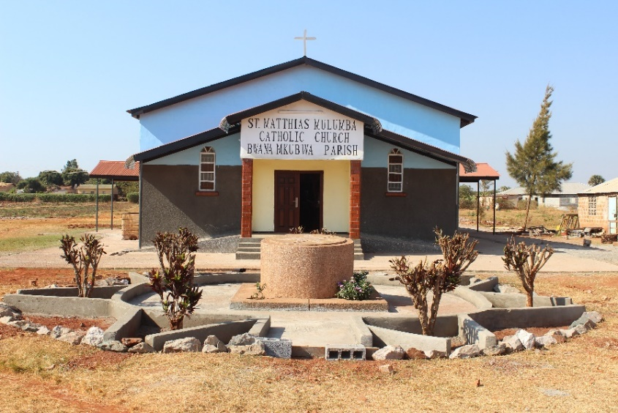
The outside of the First Church building after undergoing renovations as it today
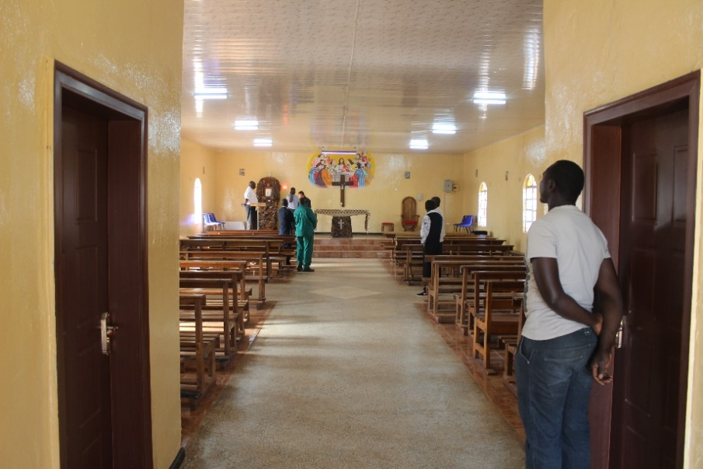
The inside of the Church building after renovations as it stands today
New Developments:
The piece of land where it is enshrined as the birthplace of the catholic Diocese of Ndola is measuring 107metres by 122metres. With this piece of land, a Shrine would be built for all the faithful of the Diocese to have an opportunity of making faith journeys in terms of pilgrimages.
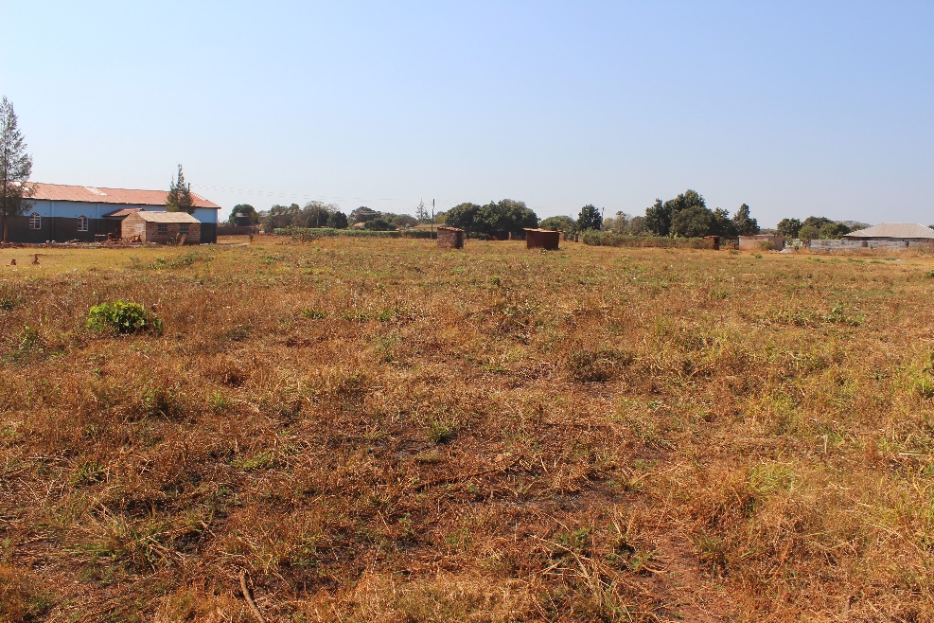
The 107m X 122m piece of land at Bwana Mkubwa
The Catholic Diocese of Ndola has already initiated the plans of building a Shrine by inviting a Korean Missionary Fr. Kim Hank to spearhead the building of the said Shrine.
Initial preparations have commenced with the drilling of the borehole and erection of the water tank for the place:
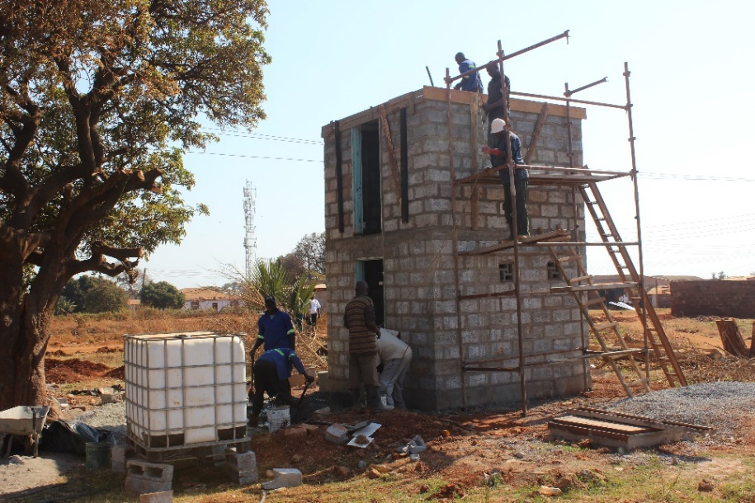
The ongoing building of the water tank stand at Bwana Mkubwa
The Diocese as of today:
The Diocese covers the whole of Copperbelt Province with an area of 32,00km with a total population of 2.5million people in the ten Districts if Ndola, Kitwe, Masaiti, Mpongwe, Luanshya, Mufulira, Chingola, Kalulushi, Chililabombwe and Lufwanyama.
The Diocese is divided into ten Vicariates (Deaneries) namely: Bwana Mkubwa, Ndola, Luanshya, Nkana, Kitwe, Kamfinsa, Mufulira, Nkana, Chingola and Chililabombwe. The Diocese consists of an estimated 1,300,000 Catholics spread out in 81 parishes, with more than 1350 Small Christian communities.
There are 101 Diocesan Priests, 70 Religious Priests, 160 male Religious and 350 Woman Religious and Consecrated men and women working in 81 parishes, 6 Mission Hospitals, 1 Leprosarium, 1 School for the deaf and dumb, 7 Secondary schools, Several Basic and Kindergarten Schools, 1 Home for the Physically challenged Persons, and Day care Centres for Physically and Mentally challenged Persons, Orphanages, Home Craft Centres, Homes for the Abused Women and Girls, 4 Pastoral Centres and 2 Youth Centres.
ADULT LAY GROUPS:
- Legio of Mary
- Secular Franciscan Order
- Actio
- Pioneer
- Nazareth
- St. Anna
- St. Joachim
- Catholic Women’s League
- Ludoviko
- Vincent De Paul
- Marriage Encounter
- St. Joseph the Worker
- Militia Immaculata
- Good Samaritans
- Catholic Charismatic Renewal

YOUTH LAY GROUPS:
- Junior Legio
- Junior Franciscan (Jufra)
- Junior Action
- Junior Pioneer
- Fred’s Family
- Altar Servers
- Stellas
- Daughters of Mary
- Vocation Club
- Xaverian Movement
- YES (Youth Encounter Saviour)
- Scouts ***

MAJOR SUPERIORS OF RELIGIOUS CONGREGATIONS
AND ECCLESIAL MOVEMENTS
CATHOLIC DIOCESE OF NDOLA

NO | CONVENT | ADDRESS | PHONE | CELL
1 | ASS. PP. JOHN XXIII | BOX 72055  NDOLA | apg23.zambia@gmail.com  smaradini@gmail.com | 0967424898
2 | BAPTISTINE CSJB | BOX 21026 KITW | csjb@zamnet.zm | 0966723281
3 | BETHANY | BOX 250005  NDOLA | bethanysisters@yahoo.com | 0975182368
4 | DAUGHTER-REDEEMER | BOX 22809  KITWE | sallynjakawaka@yahoo.com | 0963310278
5 | DISCIPLES OF JESUS | BOX 90256  LUANSHYA | djmishikishi@hotmail.es  jandisci14@gmail.com | 0966893307  0974067774
6 | DOMINICAN OP | BOX 70235  NDOLA | regoffice@zamtel.zm | 0979581444
7 | FRANCISCANS FMSA | BOX 250062  NDOLA | sfma@zamtel.zm | 0968431356
8 | FRANCISCANS FMSS | BOX 40940  MUFULIRA | fmssmuf@yahoo.com | 0966902927
9 | FRANCISCANS  FMBS | BOX 22183  KITWE |  | 0964687865
10 | GOODSHEPHERD | BOX 22809  KITWE |  | 0965967587
11 | HOLY CROSS | BOX 20974  KITWE | angelasianga@yahoo.co.uk | 0977606332
12 | CHILD JESUS | BOX 73585  NDOLA | namfukwesabina@gmail.com | 0960819176
13 | SISTERS OF CHARITY | BOX 70785  NDOLA | tscndola@iconnect.zm | 0968803456
14 | MISS OF AFRICA SISTERS | BOX 70244  NDOLA
15 | SACRED HEART | BOX 71293  NDOLA |  | 0966361111
16 | SECU INST EVANG | BOX 20694  KITWE | odinacruz@zamtel.zm | 0966648182
17 | CHRISTIAN BROTHERS | BOX 40479  MUFULIRA | cbmuf@zamtel.zm  mik.odonnchu@gmail.com
18 | MARIAN HILL | BOX 73  CHAMBISHI | fremubangacmm@yahoo.com | 0966661130  0955148844
19 | FRANCISCAN OFM CONV | BOX 70922 NDOLA | provsecretary@ofmconv.org.zm  minprov@ofmconv.org.zm | 0966447294  0969525789
20 | MARIST BROTHERS | BOX 200209  CHIBULUMA | stevegot@gmail.com | 0969222746
21 | MISS OF AFRICA WF | BOX 72125  NDOLA | pietvanheijst@gmail.com | 0979665697
22 | SALESIANS | BOX 11069  CHINGOLA | sdbchingola@zamnet.zm | 0965200566
23 | SMA | BOX 70365  NDOLA | guschisenga@yahoo.co.uk | 0975739743
24 | JESUITS | BOX 29342 | petercarroll@iconnect.zm | 0978449789
25. | Neocatechumenal Way | P.O. Box 20321, Kitwe, 4-6 Enos Chomba Avenue | e-gstalt@gmail.com | 0966 780599
26. | Focolare Movement (Opus Mariae) | 11 Nyimba Crescent, Kansenshi, Ndola  P.O. Box 70303, Ndola | hearthzambia@gmail.com | 0960364209 0973 375087  096 1819987

